**Lab Assignment 4**

Name – Shubham Konar

Roll – 1928320

Sec – CSSE 4

Group 2

1.

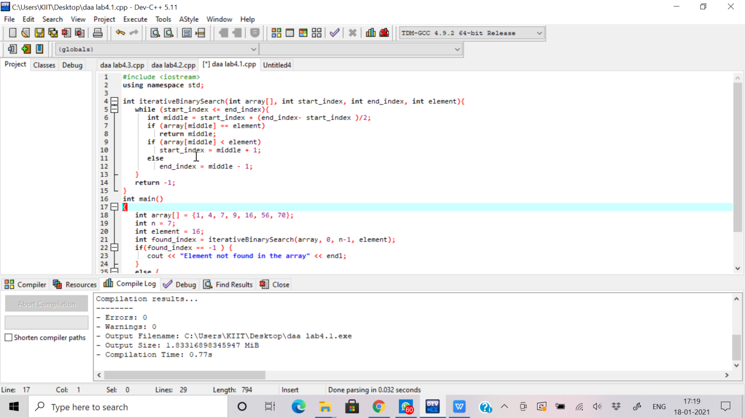

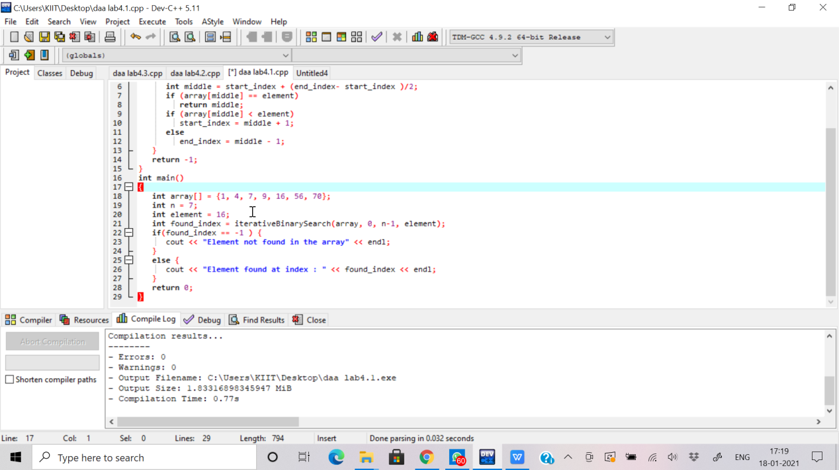

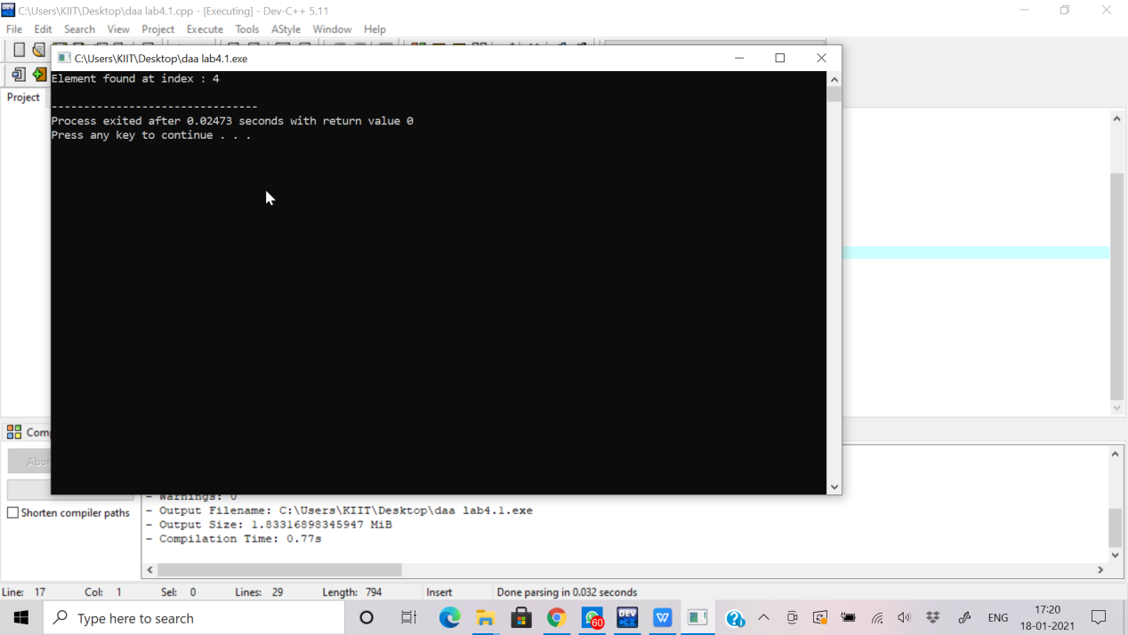Output:

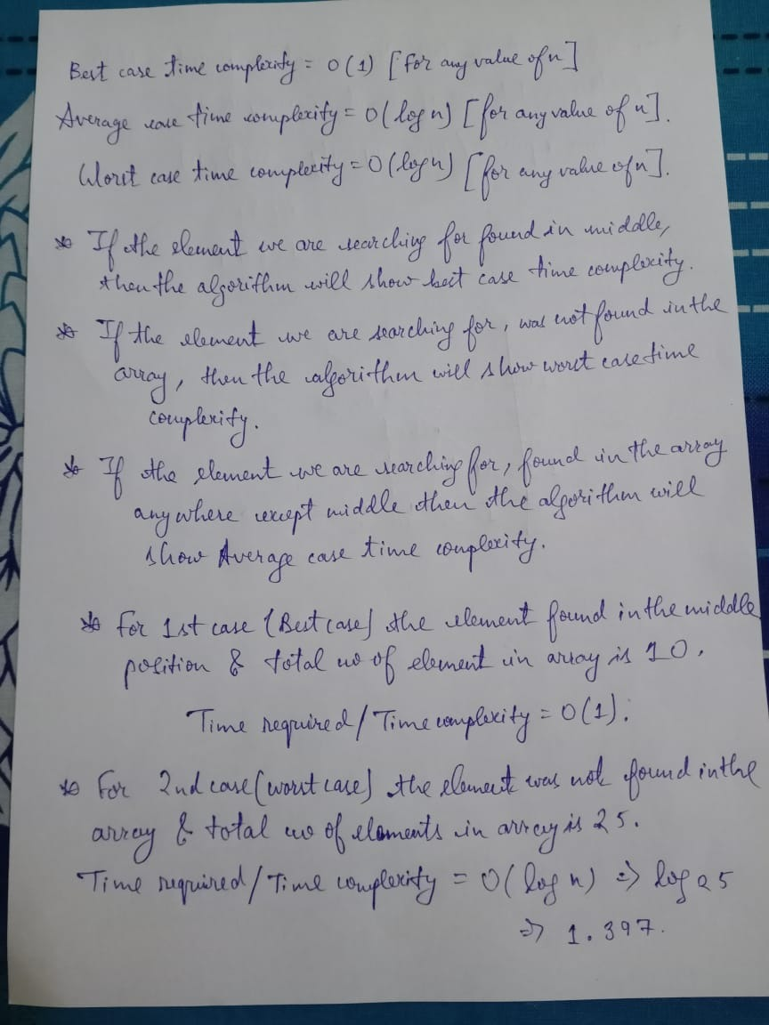

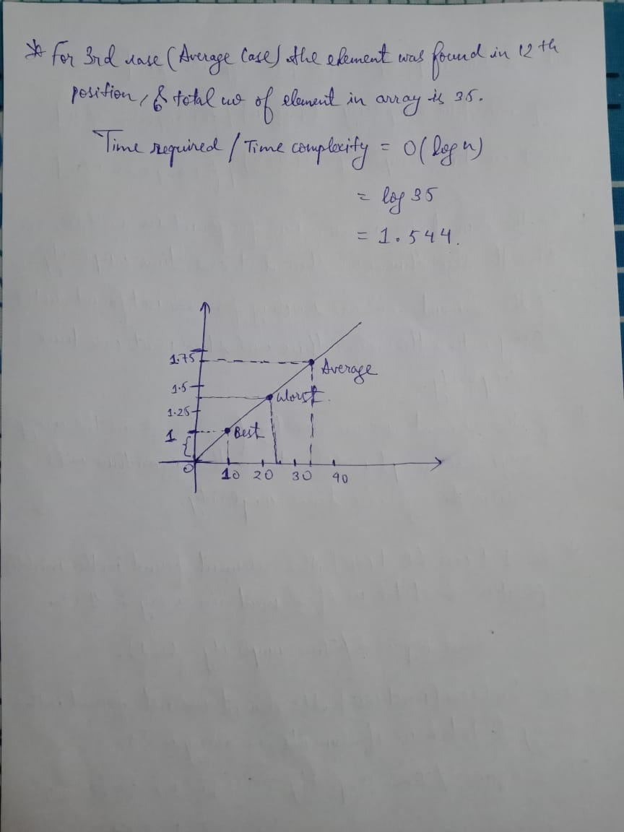

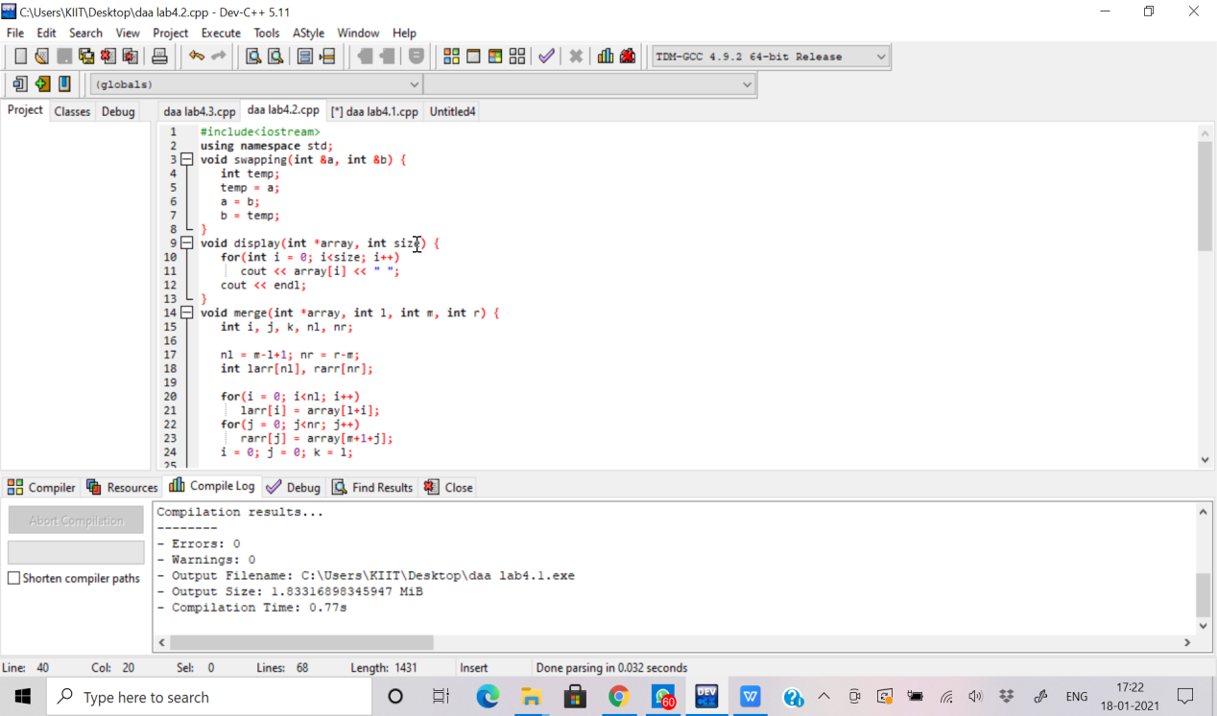2.

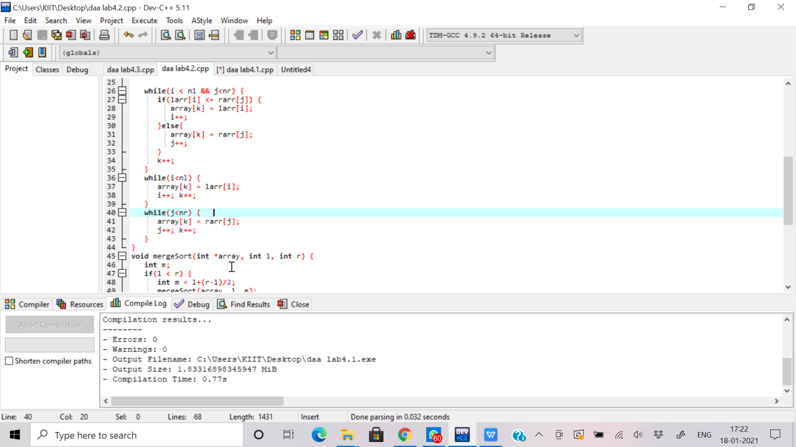

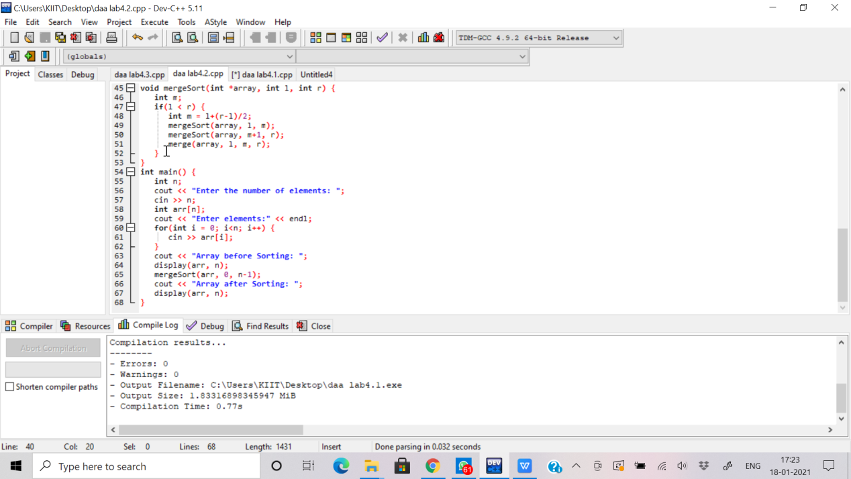

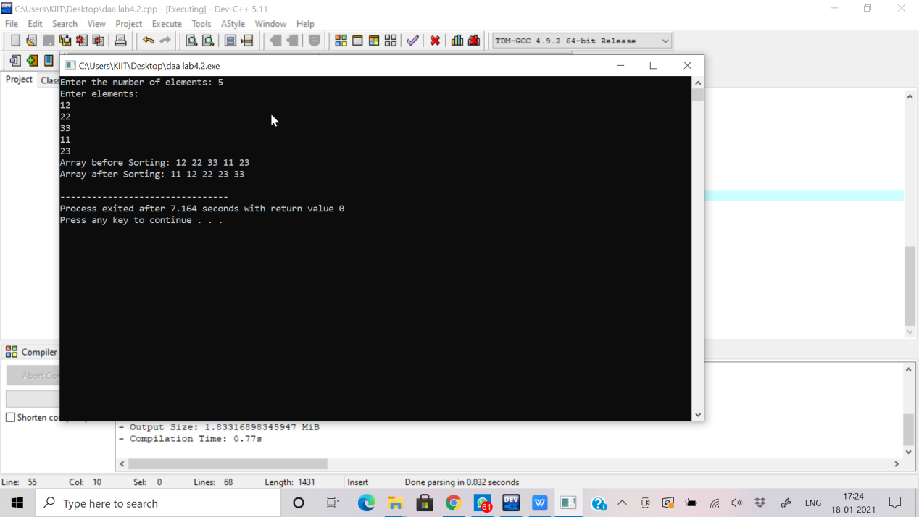Output:

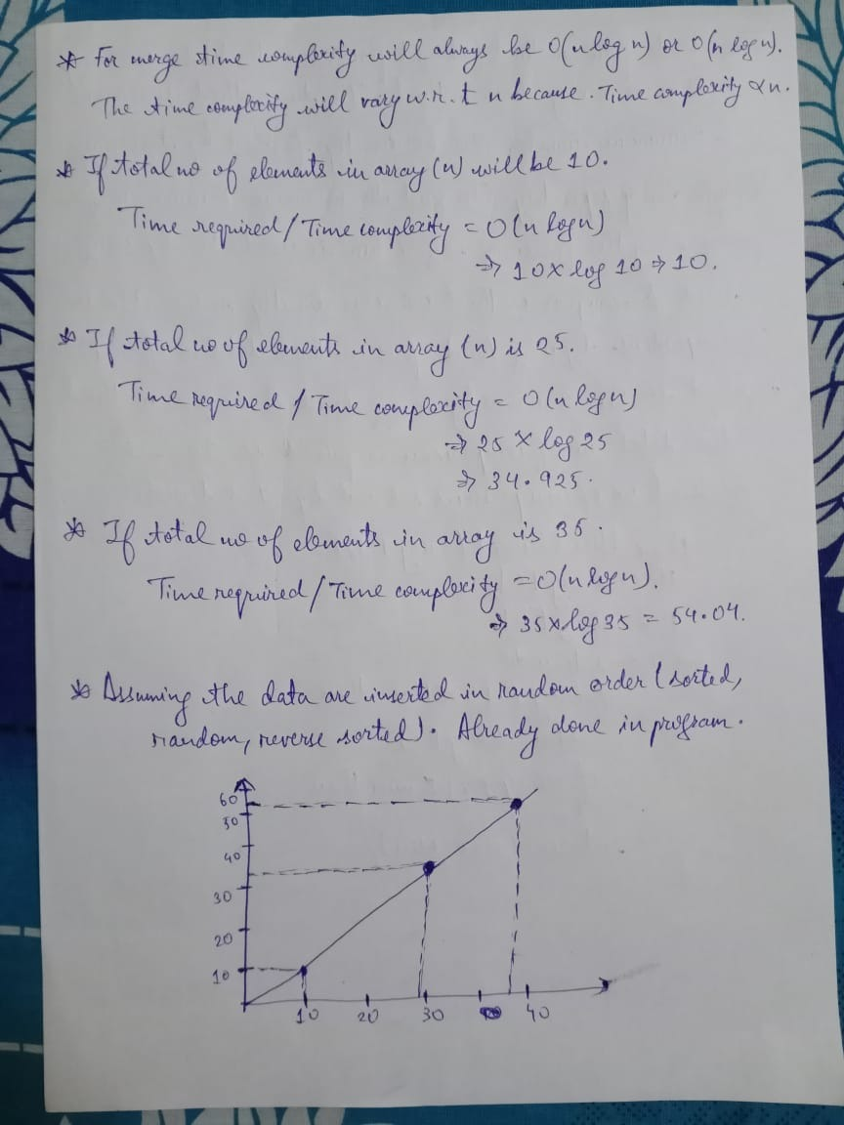

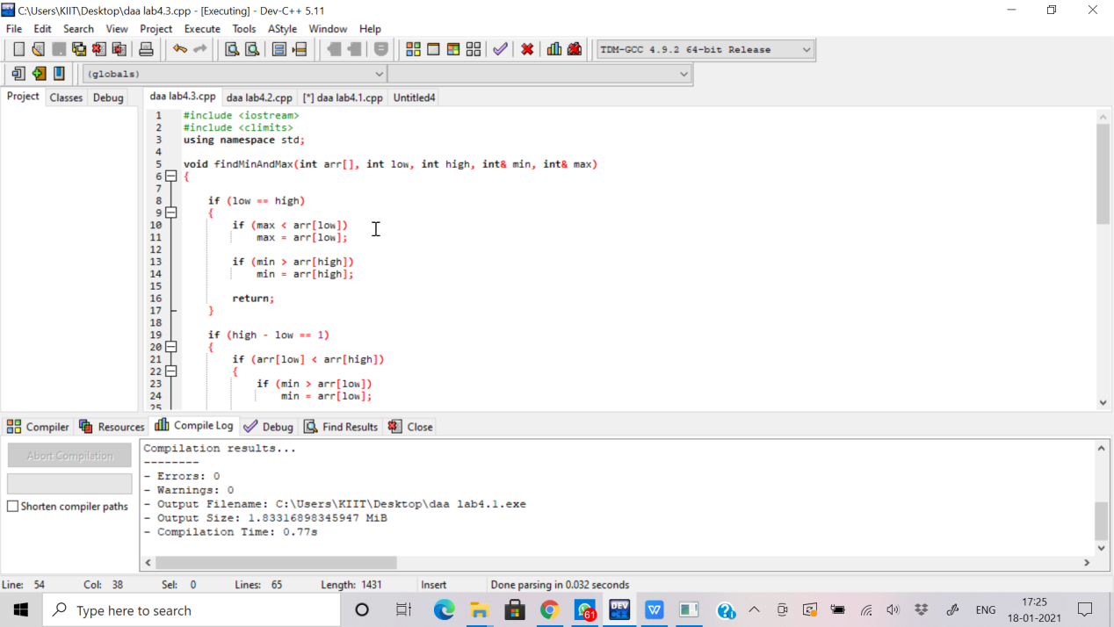3.

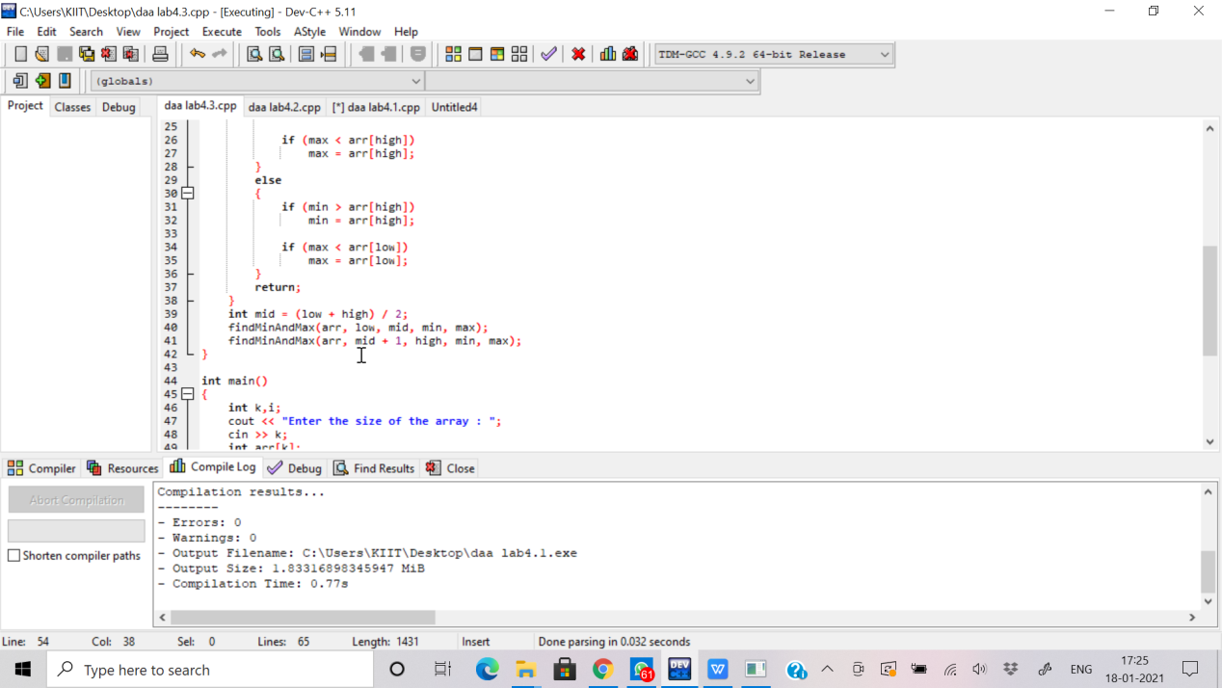

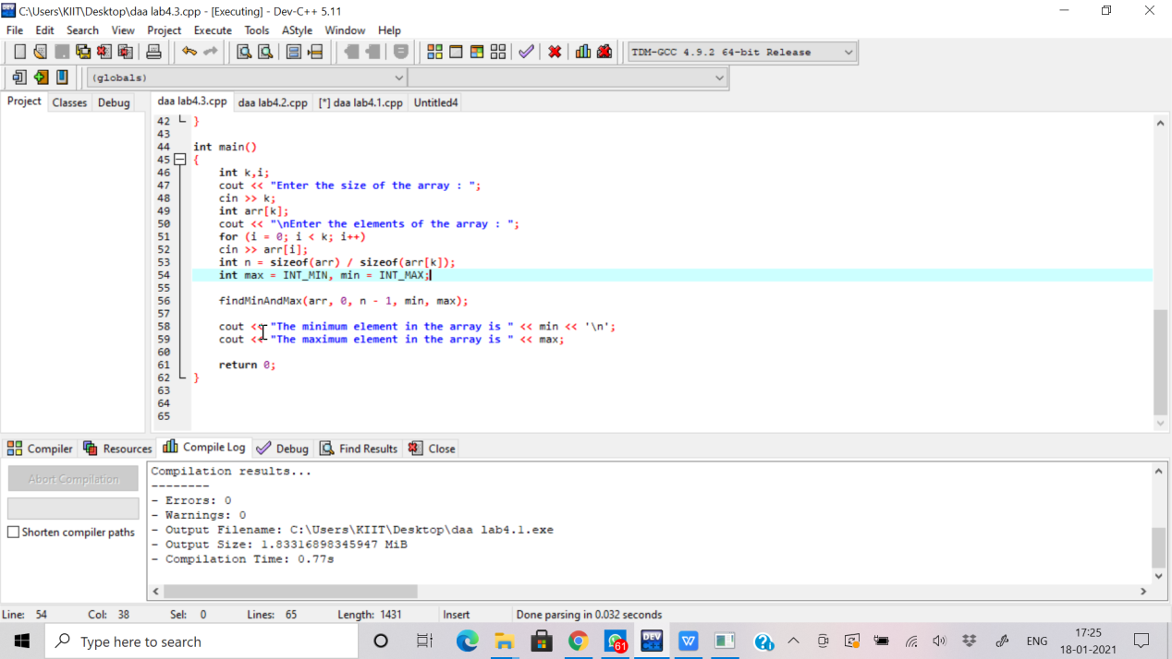

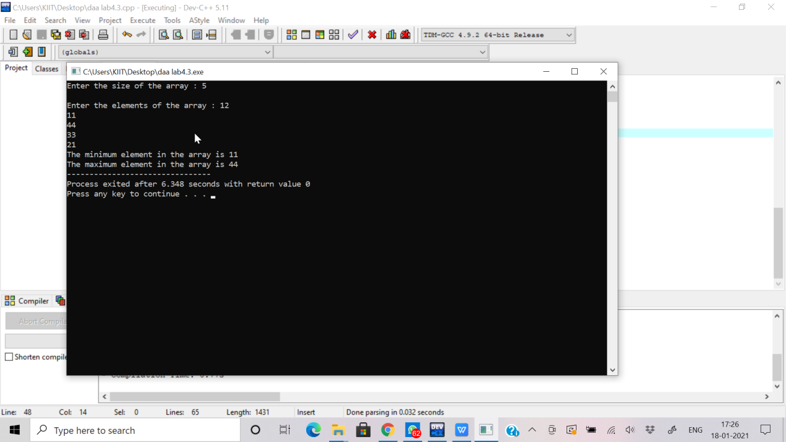Output:

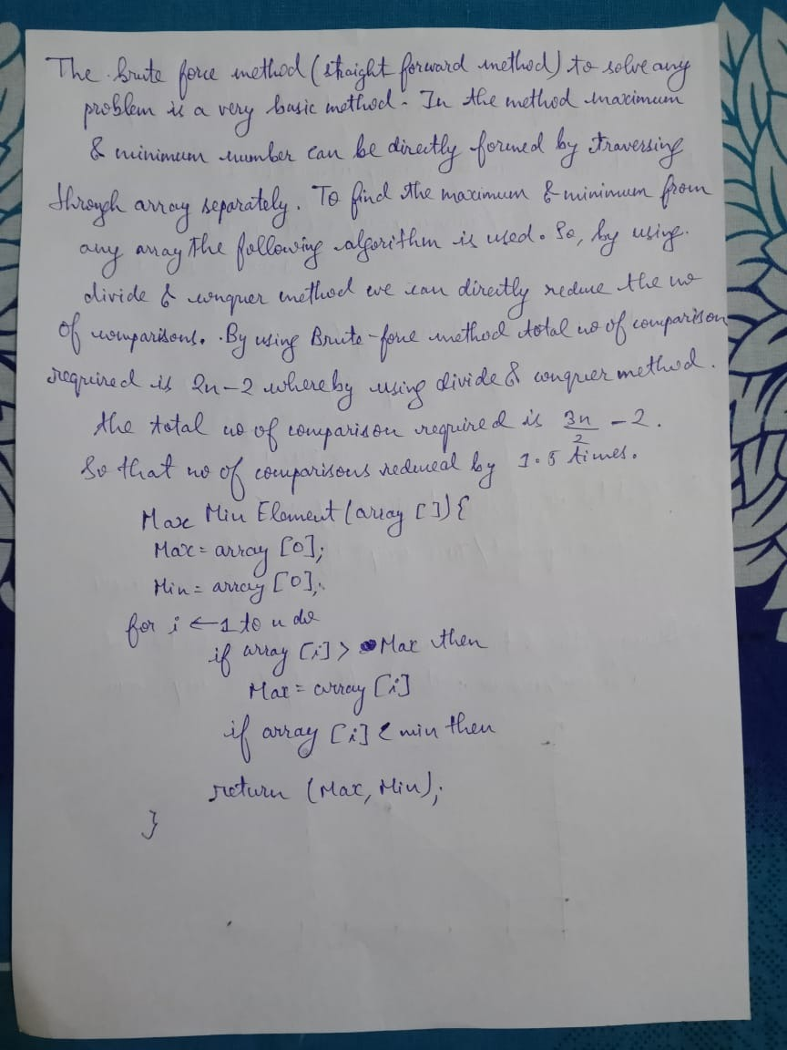

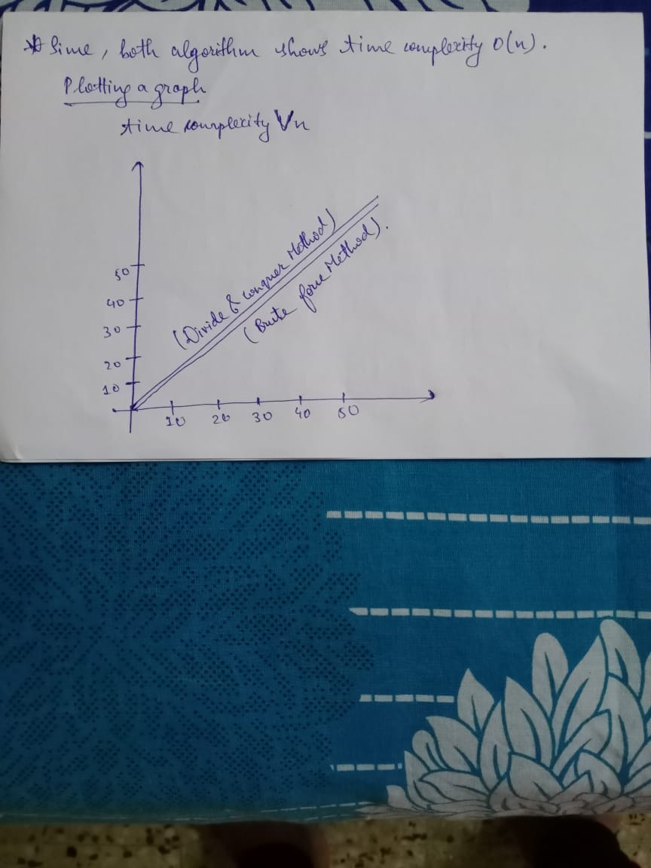

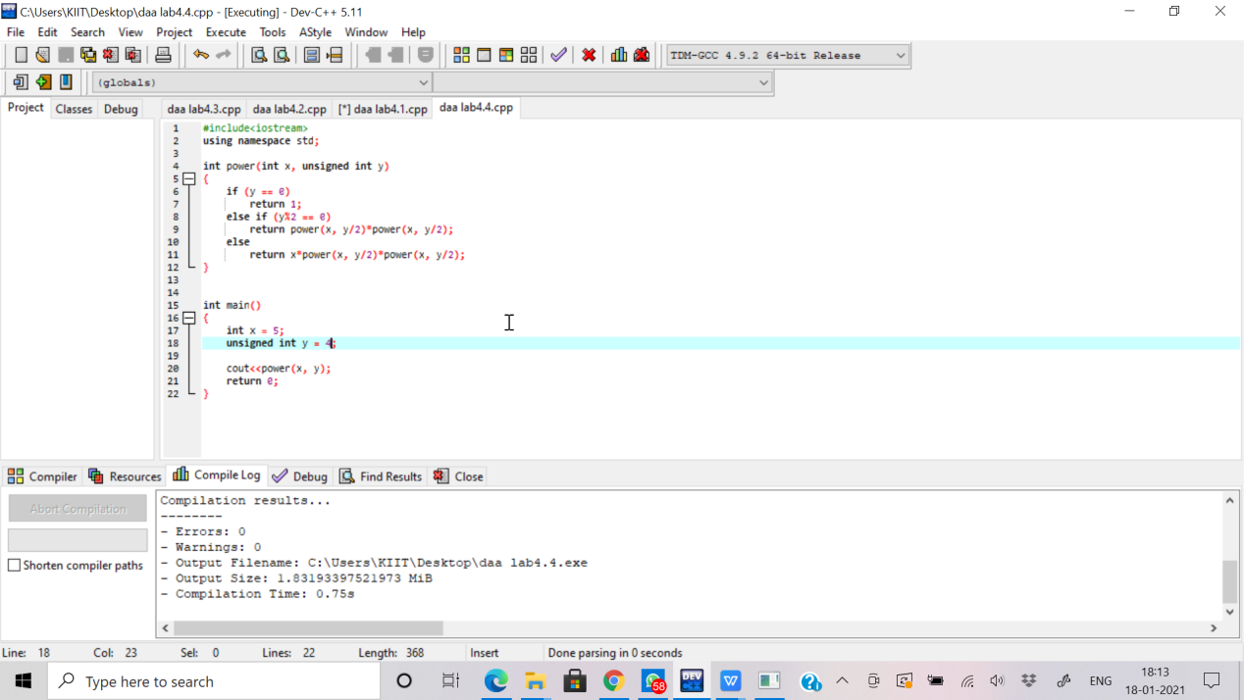4.

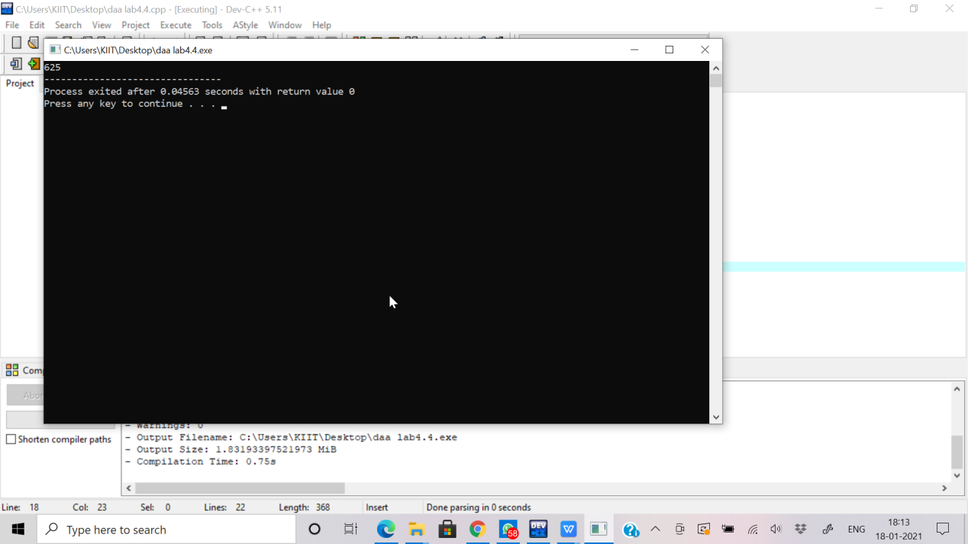Output:

The brute-force method(or straight forward method) for solving this

exponential problem will take much more time than the above

method. The brute-force algorithm will multiply the number with

itself for n times which will lead to O(n) time complexity. But above

divide and conquer algorithm will change the scenario and reduce

the time complexity to O(log n). Just say, if we want to calculate

2^8. The brute-force method will multiply the number 2 with itself

for 8 times which will lead to 8 multiplications and the complexity

will increase rapidly. But in divide and conquer method, the power

will be squared each time rather then multiplying the number n

times.

Prod = (((2)^2)^2)^2.

The multiplication will only be performed 3 times and the

complexity will lead to 3log(8) not 8 times.